COMMON COURSE ASSIGNMENT FORMAT

A. Assignment Information

Particular | Details
Department:
Programme:
Course Code & Course Name
Academic Year / Batch
Faculty Name
Assignment Title
Date of Issue
Date of Submission
Maximum Marks | 100
Course Outcome(s) – CO
Bloom's Taxonomy Level
SDG Mapping (SDG 1-17)
Industry / Societal Relevance

B. Assignment Problem / Challenge
Faculty shall provide a realistic engineering/scientific/computing problem, case, challenge or design requirement related to the Course Outcome.
The assignment should preferably require students to:

● Apply course concepts rather than reproduce theory.
● Identify and analyze the problem.
● Consider requirements and constraints.
● Develop or compare alternative solutions where appropriate.
● Use relevant modern engineering/computing/design tools.

● Interpret results.
● Make and justify engineering decisions.
● Consider appropriate technical, economic, environmental, societal, ethical, safety or sustainability factors wherever relevant

C. Problem Statement

Problem / Case / Design Challenge:
Assess the security posture of a mid-sized FinTech company's online banking infrastructure, including the customer-facing web application, Windows-based transaction-processing servers, Linux-based core-banking database server, and branch-office wireless network. The assessment must be performed in an isolated and authorized virtual laboratory using a publicly available ethically sourced intrusion/network-traffic dataset and appropriate cybersecurity tools. The objective is to identify vulnerabilities, analyze associated risks, compare Windows and Linux security postures, and propose a hardened architecture with appropriate security controls.

D. Requirements and Constraints
Students shall identify or be provided with relevant requirements and constraints. Examples include:
● Functional requirements
- Identify realistic attack patterns relevant to financial-services infrastructure using a publicly available intrusion/network-traffic dataset.
- Perform non-destructive host discovery, ping sweeps, port scanning, and service enumeration.
- Build an asset and service inventory for Windows and Linux servers.
- Assess the customer-facing web application for common vulnerabilities such as injection, authentication, and session-management weaknesses.
- Evaluate the authentication and encryption strength of the branch-office wireless network.
- Examine Windows and Linux servers for platform-specific security weaknesses.
- Prepare a prioritized risk register based on likelihood and business impact.
- Design a hardened network architecture and validate at least two identified weaknesses before and after remediation.
- Technical constraints
- Limited computing resources and laboratory time.
- Testing is restricted to the authorized virtual environment.
- Tool results may contain false positives and require analysis.
- The assessment may not represent all vulnerabilities present in a real production banking environment.
● Resources
- Computer capable of running multiple virtual machines.
- Kali Linux security-testing environment.
- Windows Server virtual machine.
- Linux Server virtual machine.
- Vulnerable web application/lab environment.
- Isolated network environment.
● Technical Requirements
- Kali Linux
- Nmap
- hping3
- Burp Suite Community / OWASP ZAP
- Nikto
- Aircrack-ng
- VirtualBox / VMware
- Windows and Linux virtual machines
● Reliability
- Security testing should not disrupt legitimate services within the laboratory.
- Proposed security controls should maintain availability of banking services.
● Ethical considerations
- Testing must remain within the authorized scope.
- No unauthorized systems or networks shall be scanned.
- Denial-of-service and destructive attacks shall not be performed.
- Identified vulnerabilities shall be handled through responsible disclosure.
● Security/privacy
- Testing shall be performed only on authorized systems.
- The laboratory environment shall be isolated from production networks.
- Real customer information, banking credentials, and financial data shall not be used.
- Testing shall be non-destructive.
- Assessment results and collected evidence shall be kept confidential.
Only constraints relevant to the particular course/problem need to be considered.

E. Student Work

1. Problem Understanding and Formulation
Explain:
● What is the problem?
The security challenges associated with the FinTech banking infrastructure.
● What are the expected outcomes?
The expected outcome is about how we solve the problem related to the Fin Tech Banking system and the tools we use to solve the problem in an efficient way.
● What information/data is available?
The available intrusion/network-traffic dataset and its relevance to banking security.
● What assumptions are made?
The assumptions made regarding the isolated virtual laboratory.
● What constraints must be satisfied?
The security, ethical, legal, and technical constraints that must be satisfied.

2. Application of Course Knowledge

Identify and apply the relevant:

● Principles
CIA Triad (Confidentiality, Integrity, Availability), least privilege, defense-in-depth, authentication, authorization, and secure communication.
● Theories
Ethical hacking, vulnerability assessment, network reconnaissance, threat assessment, and risk assessment
● Mathematical models
Risk assessment using Risk = Likelihood × Impact for prioritizing identified vulnerabilities.
● Algorithms
Host discovery, ping sweep, port scanning, service enumeration, and attack-pattern identification.
● Engineering concepts
Network segmentation, firewall configuration, access control, server hardening, patch management, HTTPS/TLS, secure wireless authentication, and centralized security monitoring.
● Design methodologies
Risk-based security assessment, defense-in-depth, secure network architecture, and security hardening.

Show necessary calculations, derivations or reasoning.

3. Solution / Design / Methodology

Develop the proposed solution. Depending upon the nature of the course, this may include:

● Algorithm
Design a hardened FinTech network architecture with network segmentation, firewalls, access controls, secure wireless authentication, HTTPS/TLS, and centralized security monitoring.
● Design
Design appropriate security controls and a hardened architecture based on the identified risks.
● Experiment
Perform non-destructive host discovery, ping sweeps, port scanning, service enumeration, web security assessment, wireless security assessment, and Windows/Linux security assessment in an authorized virtual laboratory.
● Architecture
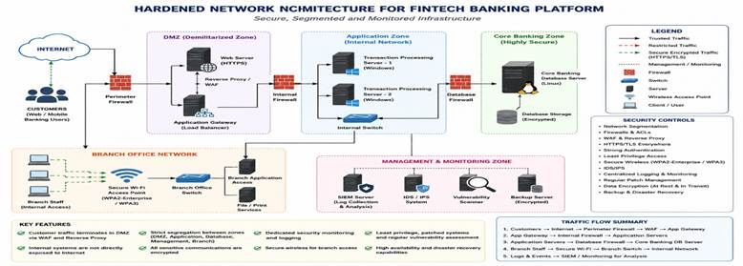
● Process
Follow a systematic security assessment process consisting of dataset analysis, reconnaissance, vulnerability identification, risk assessment, security hardening, and validation.
● Simulation
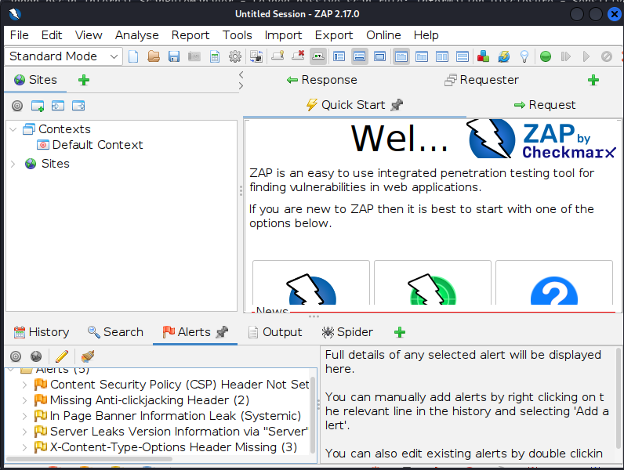
● Case analysis
Analyze the security posture of the FinTech banking infrastructure and identify realistic attack patterns and vulnerabilities affecting web applications, Windows servers, Linux servers, and wireless networks.
● Data analysis
Analyze the selected network-traffic/intrusion dataset to identify relevant attack patterns and interpret the security assessment results.

Where appropriate, consider more than one possible solution.

4. Use of Modern Tools
- Kali Linux – security testing and assessment platform.
- Nmap – host discovery, ping sweeps, port scanning, and service enumeration.
- hping3 – network connectivity testing and controlled packet-based discovery.
- Burp Suite Community Edition – web application security testing.
- OWASP ZAP – web vulnerability assessment.
- Nikto – web server security assessment.
- Aircrack-ng – wireless network security assessment in the authorized laboratory.
- Wireshark – network traffic capture and analysis.
- Python – analysis of the selected intrusion/network-traffic dataset.
- VirtualBox / VMware – creation of the isolated virtual laboratory environment.

5. Results and Validation
Present the results using appropriate:
● Screenshots
Network assessment
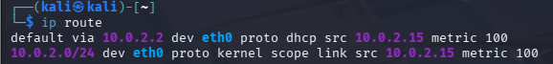
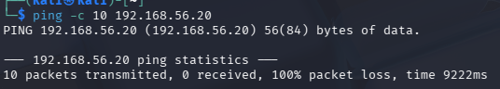
sudo nmap -sV
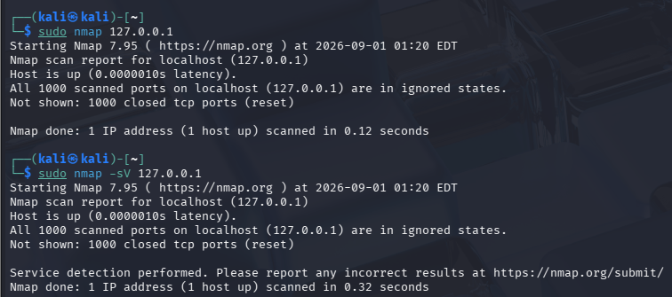
hping3
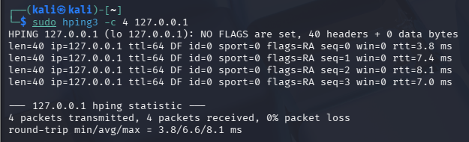
Nikto
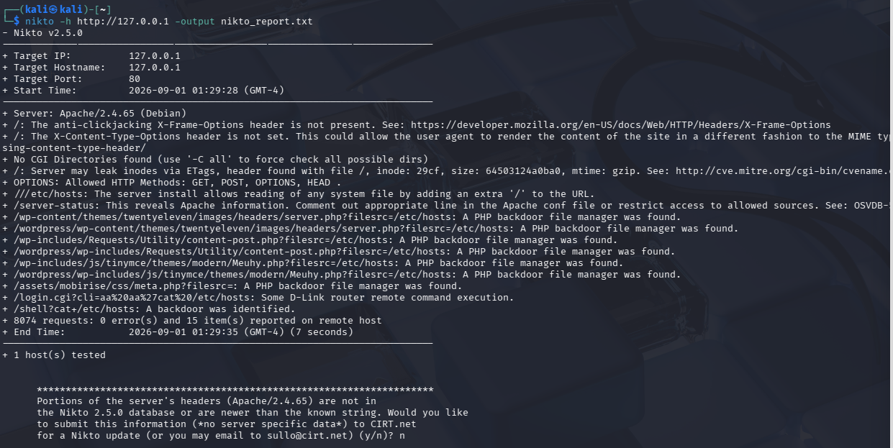

OWASP ZAP Alerts

Linux Services
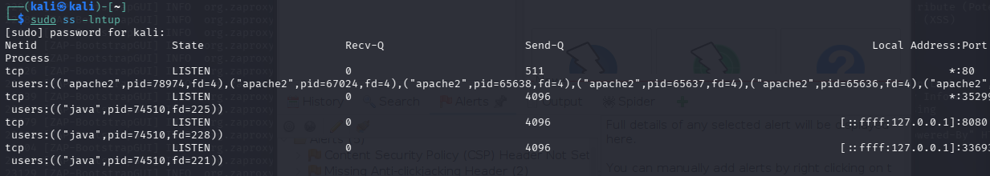
Firewall
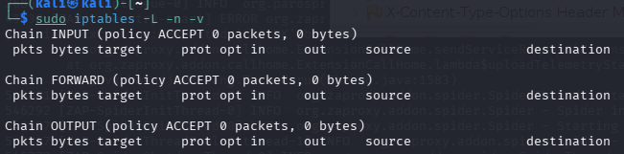
Patch Status
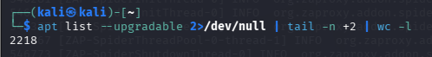
Before/After Security Headers
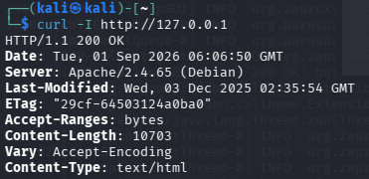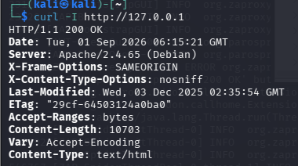
Before After

Validate whether the proposed solution satisfies the stated requirements.

6. Analysis and Engineering Decision

● Compare alternatives.
- Two security approaches were considered. The first was perimeter-based protection using firewall rules and network controls. The second was a defense-in-depth approach combining firewall controls, secure web-server configuration, patch management, access control, network segmentation, and security monitoring. The defense-in-depth approach was selected because it provides multiple layers of protection against different attack vectors.
● Identify advantages and limitations.
- The assessment tools provided practical visibility into the security posture of the system. Nmap helped identify hosts, ports, and services; hping3 supported connectivity testing; Nikto and OWASP ZAP identified web-server security issues; and Linux commands helped assess services, firewall configuration, NFS, permissions, SUID files, and patch status. A limitation is that the laboratory did not contain a dedicated Windows Server, banking database, or branch wireless network, so those components could not be practically tested.
● Discuss trade-offs.
- Security improvements can increase configuration and maintenance requirements. Strict firewall rules and network segmentation may restrict legitimate connectivity, while regular patching may require service downtime. Stronger security controls can also increase administrative complexity. However, these trade-offs are acceptable in a FinTech environment because protecting financial information and banking services has higher priority than minimizing configuration effort.
● Explain why the final solution was selected.
- The defense-in-depth hardened architecture was selected because the assessment identified web-server configuration weaknesses and exposed services. The solution combines secure HTTP headers, reduced server information disclosure, patch management, firewall controls, network segmentation, secure authentication, and centralized monitoring. This approach reduces the attack surface and limits the impact of a successful attack.
● Justify the decision using quantitative or qualitative evidence.
- The decision was supported by the tool-generated evidence collected during the assessment. Nmap identified the available services, while Nikto and OWASP ZAP reported missing security headers and server information disclosure. The Linux assessment identified 2,218 upgradable packages and showed that firewall filtering was not enforced through the tested iptables configuration. Before-and-after validation demonstrated that X-Frame-Options and X-Content-Type-Options were successfully added, and detailed Apache version information was reduced after hardening. These results demonstrate an improvement in the security configuration of the tested environment.

7. Broader Considerations

Where relevant to the problem, discuss the impact of the proposed solution with respect to:

● Sustainability
- The proposed security architecture supports sustainable IT operations by reducing security incidents, system downtime, and the resources required to recover from attacks. Regular patching and centralized monitoring also help maintain systems efficiently over their lifecycle and mainly SDG 9 Industry, Innovation and Infrastructure is being used.
● Environment
- A well-designed security infrastructure can reduce unnecessary hardware replacement and downtime by preventing security incidents. Using virtualized security testing environments also reduces the need for additional physical systems during assessment.
● Society
- Protecting FinTech systems helps safeguard customers' financial information and maintains trust in digital banking services. Improved security also reduces the potential impact of fraud, data breaches, and service disruption on customers.
● Safety
- Security controls such as network segmentation, firewall restrictions, secure authentication, HTTPS/TLS, and regular patching reduce the likelihood of unauthorized access and protect critical financial services.
● Ethics
- All security testing was performed within an authorized laboratory environment. No unauthorized systems or real banking infrastructure were targeted. Customer confidentiality, responsible disclosure, and appropriate handling of security information were considered throughout the assessment.
● Economics
- Although implementing security controls requires financial and administrative resources, the cost is justified because security incidents can result in financial loss, regulatory penalties, service downtime, and reputational damage.
● Accessibility
- The proposed security controls should maintain legitimate customer and employee access while restricting unauthorized activities. Security mechanisms should be designed so that genuine users can access required banking services without unnecessary difficulty.
● Professional responsibility
- Security professionals must perform assessments only within authorized scope, protect sensitive information, document findings accurately, and report vulnerabilities responsibly. The assessment followed these principles by using a controlled laboratory environment and avoiding unauthorized testing.

8. Conclusion
Summarize:

● Proposed solution
- A defense-in-depth security architecture was proposed for the FinTech environment, including network segmentation, firewall and access-control policies, HTTPS/TLS, secure wireless authentication, regular patch management, server hardening, and centralized security monitoring.
● Major findings
- The assessment identified web-server security configuration weaknesses, including missing HTTP security headers and detailed Apache version disclosure. Linux assessment also identified exposed services, an inactive host-level firewall configuration, and a large number of available package updates. NFS and the tested critical file permissions did not show obvious weaknesses.
● Achievement of requirements
- The authorized laboratory assessment successfully demonstrated host discovery, port scanning, service enumeration, hping3 testing, web-server assessment using Nikto and OWASP ZAP, and Linux security assessment. Two identified Apache weaknesses were successfully hardened and validated using before-and-after testing.
● Limitations
- The practical environment did not contain a dedicated Windows Server, production banking database, or branch-office wireless network. Therefore, Windows-specific vulnerabilities, wireless authentication/encryption, and production banking infrastructure could not be directly tested. The assessment results should therefore not be considered a complete production-bank security audit.
● Possible improvements
- Future work can include testing a dedicated Windows Server, Linux database server, and WPA2-Enterprise/WPA3 wireless environment. Additional improvements could include continuous vulnerability scanning, centralized SIEM monitoring, intrusion detection, stronger authentication, automated patch management, and periodic authorized penetration testing.

ID | Finding | Evidence/Tool | Likelihood | Impact | Risk | Recommended Action
R1 | Missing security headers | OWASP ZAP | Medium | Medium | Medium | Configure security headers
R2 | Apache version disclosure | Nikto/ZAP | Medium | Low | Medium | Hide detailed server version
R3 | Large number of pending updates | APT | High | High | High | Apply regular security patches
R4 | Firewall default ACCEPT policy | iptables | High | High | High | Implement restrictive firewall rules
R5 | Exposed services | Nmap | Medium | High | High | Disable unnecessary services/restrict access
R6 | NFS not exposed | NFS check | Low | High | Low | Continue monitoring NFS configuration
R7 | Critical file permissions | Linux checks | Low | High | Low | Maintain restricted permissions
R8 | SUID executables identified | SUID check | Medium | High | Medium | Review unnecessary SUID binaries

9. Student Reflection

● What did you learn from this assignment beyond what was directly taught in the classroom?
- I gained practical experience in performing cybersecurity assessments in an authorized virtual environment. I learned how to use tools such as Nmap, hping3, Burp Suite/OWASP ZAP, Nikto, and Aircrack-ng for identifying security weaknesses. I also learned how to analyze network traffic, assess Windows and Linux vulnerabilities, prioritize risks, and design security controls for a FinTech environment.
● If you were given additional time/resources, what would you improve and why?
- With additional time and resources, I would expand the assessment to include more realistic banking infrastructure, continuous security monitoring, advanced intrusion detection, automated vulnerability scanning, and additional penetration-testing scenarios. I would also improve the before-and-after validation by conducting more security tests to measure the effectiveness of the proposed security controls.
10. References
- Nmap Project, “Nmap Network Scanning,” Nmap. [Online]. Available: https://nmap.org/. [Accessed: Sep. 1, 2026].
- OWASP Foundation, “OWASP Web Security Testing Guide,” OWASP. [Online]. Available: https://owasp.org/www-project-web-security-testing-guide/. [Accessed: Sep. 1, 2026].
- OWASP Foundation, “OWASP ZAP,” OWASP. [Online]. Available: https://www.zaproxy.org/. [Accessed: Sep. 1, 2026].
- PortSwigger, “Burp Suite Documentation,” PortSwigger. [Online]. Available: https://portswigger.net/burp/documentation. [Accessed: Sep. 1, 2026].
- Aircrack-ng, “Aircrack-ng Documentation,” Aircrack-ng. [Online]. Available: https://www.aircrack-ng.org/. [Accessed: Sep. 1, 2026].
- R. Sommer and V. Paxson, “Outside the closed world: On using machine learning for network intrusion detection,” in Proc. IEEE Symp. Security and Privacy, 2010, pp. 305–316.
- National Institute of Standards and Technology, “Cybersecurity Framework (CSF) 2.0,” NIST, 2024. [Online]. Available: https://www.nist.gov/cyberframework. [Accessed: Sep. 1, 2026].
- National Institute of Standards and Technology, “Security and Privacy Controls for Information Systems and Organizations,” NIST SP 800-53 Rev. 5. [Online]. Available: https://csrc.nist.gov/publications/detail/sp/800-53/rev-5/final. [Accessed: Sep. 1, 2026].
- CIS, “CIS Critical Security Controls,” Center for Internet Security. [Online]. Available: https://www.cisecurity.org/controls. [Accessed: Sep. 1, 2026].
- T. Y. Yang et al., “Deep learning for network intrusion detection: A survey,” IEEE Access, vol. 9, pp. 123–145, 2021.

F. Common Assessment Rubric

Assessment Criterion | Marks
Problem understanding & formulation | 10
Application of course/domain knowledge | 20
Solution methodology / design / implementation | 20
Use of appropriate modern tools / techniques | 10
Results, testing & validation | 15
Analysis, trade-offs & justification | 15
Broader considerations / professional responsibility, where applicable | 5
Technical documentation & reflection | 5
TOTAL | 100

G. CO–PO–Assessment Mapping

Assessment Component | CO | PO(s) | Bloom's Level | Marks
Problem formulation |  |  | L3/L4 | 10
Application of knowledge |  |  | L3/L4 | 20
Solution / Design / Implementation |  |  | L4/L5/L6 | 20
Modern tool usage |  |  | L3/L4 | 10
Validation |  |  | L4/L5 | 15
Analysis & justification |  |  | L4/L5 | 15
Broader considerations |  |  | L4/L5 | 5
Documentation & reflection |  |  | L3/L4 | 5
Note: Faculty shall map only the POs and Bloom's levels genuinely assessed by the particular assignment. Every assignment is not required to map to every PO.

H. FacultyEvaluation&ContinuousImprovement

CO Attainment

Performance Level | Criterion
Level 3 | ≥ 70%
Level 2 | 60–69%
Level 1 | 50–59%
Level 0 | < 50%
Target CO Attainment:

Actual CO Attainment:

Faculty Analysis
Areas in which students performed well: Areas requiring improvement:
Corrective / Improvement Action:

Action to be implemented in the next offering:

Documents to be Maintained

The department/course faculty shall maintain:

1. Assignment question/problem statement
2. CO–PO and Bloom's mapping
3. Assessment rubric
4. Student submissions
5. Tool/simulation/experimental evidence, where applicable
6. Evaluated scripts/reports
7. Marks and rubric-wise assessment
8. CO attainment analysis
9. Sample student work representing different performance levels
10. Faculty analysis and continuous-improvement action

